PYTHON PROGRAMMING PROJECT REPORT
(Project Semester January-April 2025)

TITLE: 120 YEARS OF OLYMPICS HISTORY

Submitted by

Name: Akshat Kumar
Registration No: 12313644
Section: K23SG
Roll No: 20
Programme: BTech CSE Course Code INT375 Under the Guidance of
Name of Faculty: Dr. Manpreet Singh Sehgal
UID: 32354

Discipline of CSE/IT

Lovely School of Computer Science and Engineering


DECLARATION

I, Akshat kumar, student of BTech CSE under CSE/IT Discipline at, Lovely Professional University, Punjab, hereby declare that all the information furnished in this project report is based on my own intensive work and is genuine.

Date: 09-04-2025

Registration No. 12313644 Akshat Kumar

CERTIFICATE

This is to certify that Akshat Kumar bearing Registration no. 12313644 has completed INT375 project titled, “120 Years of Olympics History ” under my guidance and supervision. To the best of my knowledge, the present work is the result of his/her original development, effort and study.

Dr. Manpreet Singh Sehgal

Assistant Professor
School of Computer Science and Engineering
Lovely Professional University Phagwara, Punjab.

ACKNOWLEDGEMENT

I want to take a moment to express my deep appreciation for the support I have received from everyone, either directly or indirectly, for enabling me to finish this project successfully. To start, I am grateful to Dr. Manpreet Singh Sehgal for his guidance, feedback, and steady support during this project.
His guidance allowed not only for academic support but also a wealth of moral support when I needed help staying on track and maintaining my motivation. I would also like to express my gratitude to Lovely Professional University for their example and support in offering a learning experience that fosters innovation, critical thinking, and practical application.
The resources and infrastructure they provided were significant factors that enabled me to finish the project. I need to thank my family and close friends for being my backbone throughout the project. Their understanding, optimism, and faith in me provided support, especially as I experienced self-doubt and/or pressure.
Finally, I thank the individuals who provided support through growth, learning and inspiration, and hope they realize that this project does not only indicate the summation of technical knowledge and learning, but is a personal accomplishment in and of itself, that indicates growth, perseverance and passion.

Table of Content

SNO. | TITLE
1 | Introduction
2 | Source of dataset
3 | EDA Process
4 | Analysis on dataset(for each analysis)
5 | Conclusion
6  7  8 | Future scope  References  Github Link

Introduction:

The Olympic Games are one of the most celebrated sporting events in human history, bringing together athletes from all over the globe in a display of athletic excellence, unity, and cultural diversity. Since the revival of the modern Olympics in Athens in 1896, the Games have grown in scale and significance, becoming a powerful symbol of international cooperation, perseverance, and human achievement. With over a century of data encompassing multiple sports, thousands of athletes, and hundreds of nations, the Olympics offer a rich and compelling dataset that reflects not only the evolution of sports but also major socio-political and historical shifts.
This Python-based project, "120 Years of Olympic History", is designed to explore and analyze this extensive historical data. Using tools and techniques from data science and visualization, the project aims to uncover trends, patterns, and insights that have shaped the Olympic Games over the years. From identifying the most successful countries and athletes, to examining how participation has grown and diversified, to exploring the impact of global events like wars and political boycotts — this project serves as a comprehensive study of the Olympics through a data-driven lens.

To achieve these objectives, the project leverages powerful Python libraries such as pandas for

data manipulation, numpy for numerical operations, and matplotlib, seaborn, and plotly for

creating meaningful visualizations. The dataset used, which spans from 1896 to 2016, includes detailed information on athletes, events, countries, and medals, providing the foundation for a wide range of analyses.

This project not only aims to provide historical insights but also emphasizes the importance of

data storytelling. Through interactive dashboards and carefully designed visuals, the goal is to

make the Olympic legacy accessible and engaging for both sports enthusiasts and data science

learners. By bridging the gap between data and history, this project celebrates the Olympic spirit

and demonstrates the power of data analytics in uncovering stories hidden within numbers.

SOURCE OF DATASET

https://mavenanalytics.io/data-playground?accessType=open&dataStructure=Single%20table&dataStructure=Multiple%20tables&order=date_added%2Cdesc&tags=Sports

EDA PROCESS

Exploratory Data Analysis (EDA) is a critical step in any data-driven project. It helps to understand the dataset, detect patterns, spot anomalies, test hypotheses, and summarize the main characteristics of the data. For the "120 Years of Olympic History" project, the EDA process can be broken down into the following steps:

1. Data Collection and Loading
- Dataset Used: 120 years of Olympic history: athletes and results.
- Tools: pandas, numpy
- Actions:
  - Load the dataset(s) using athlete.read_csv()
  - files needed (e.g., Olympic_Athlete.zip)\

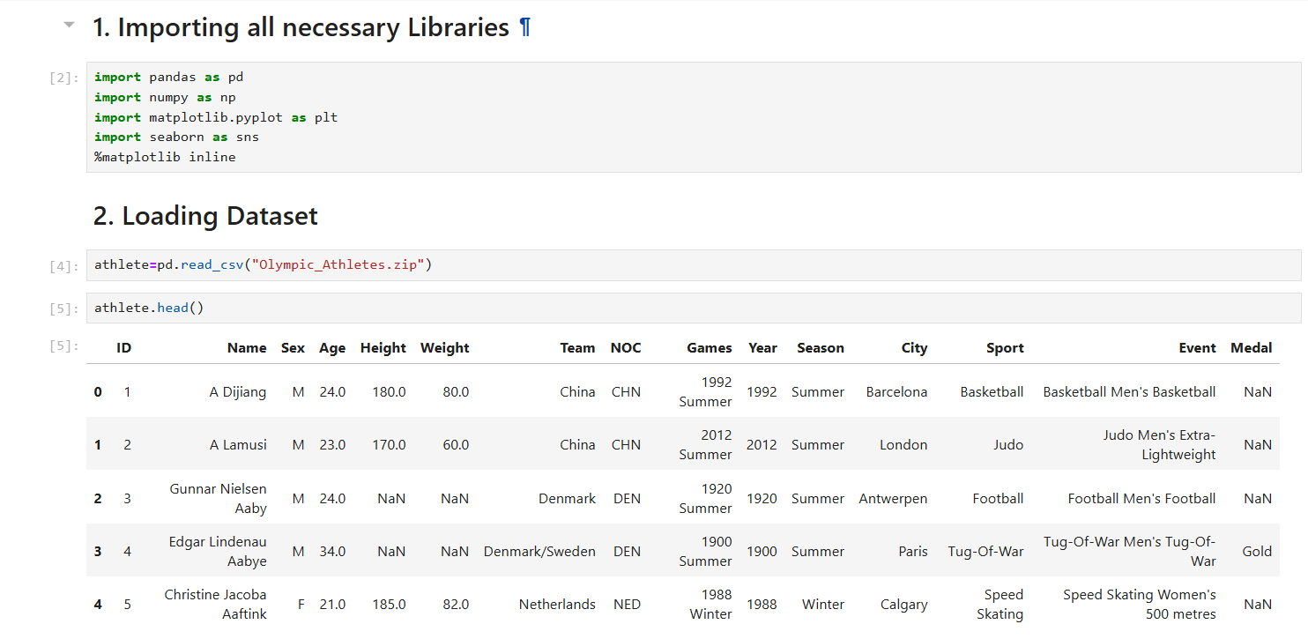

2. Initial Data Exploration
- Understand the structure:
  - Use .info(), .head(), .shape() to explore the dataset
  - Check for:
    - Number of rows and columns
    - Data types
    - Unique values in columns
- Identify key columns:
  - Athlete name, team, year, season, sport, event, medal, gender, age, height, weight, etc.

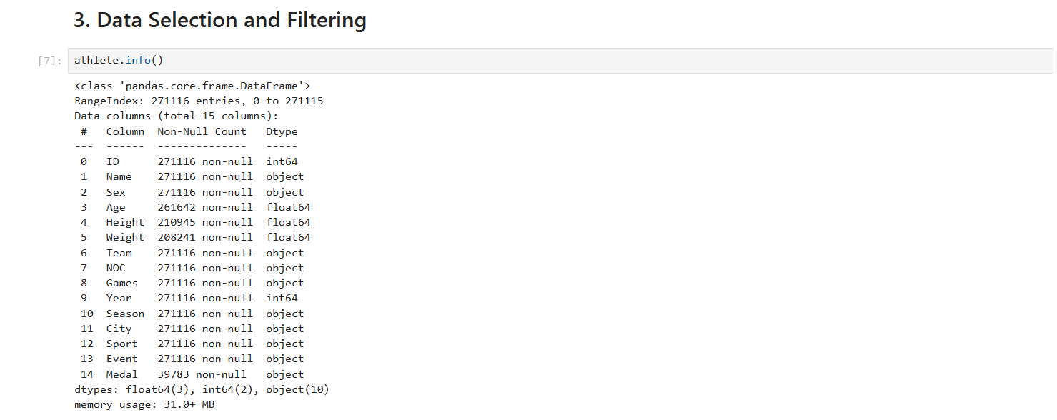

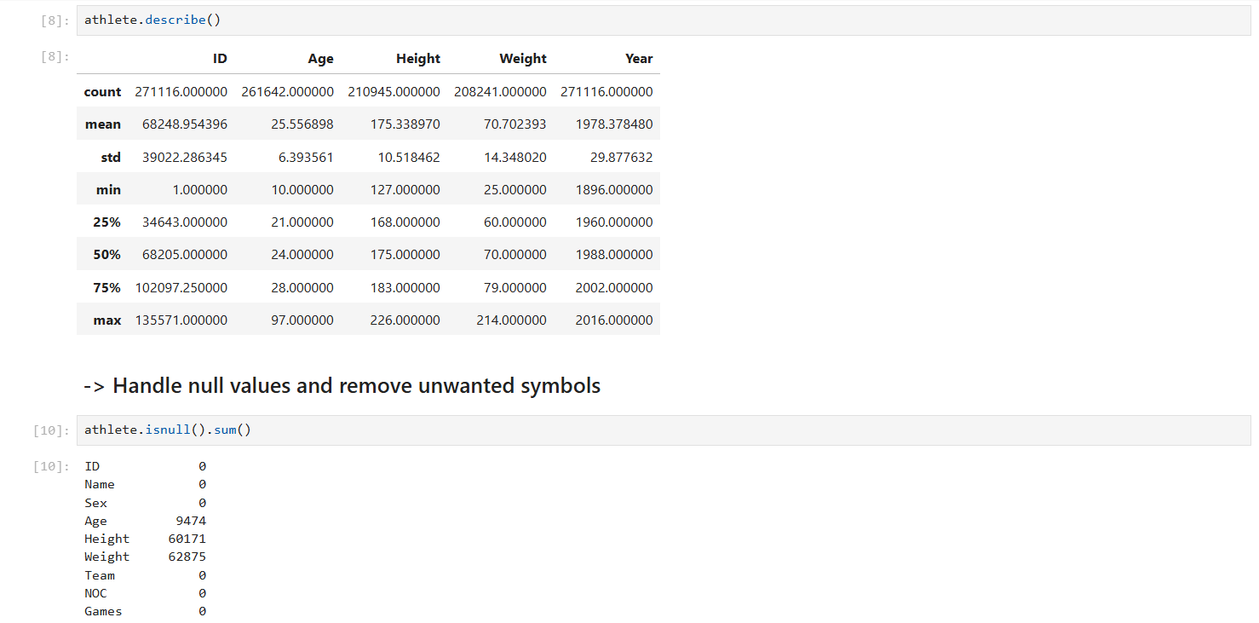

3. Data Cleaning

- Missing Values:
  - Detect missing values with df.isnull().sum()
  - Decide how to handle missing age, height, weight, or medal fields (e.g., fill, drop, or impute)
- Duplicates:
  - Use df.duplicated().sum() and remove if necessary

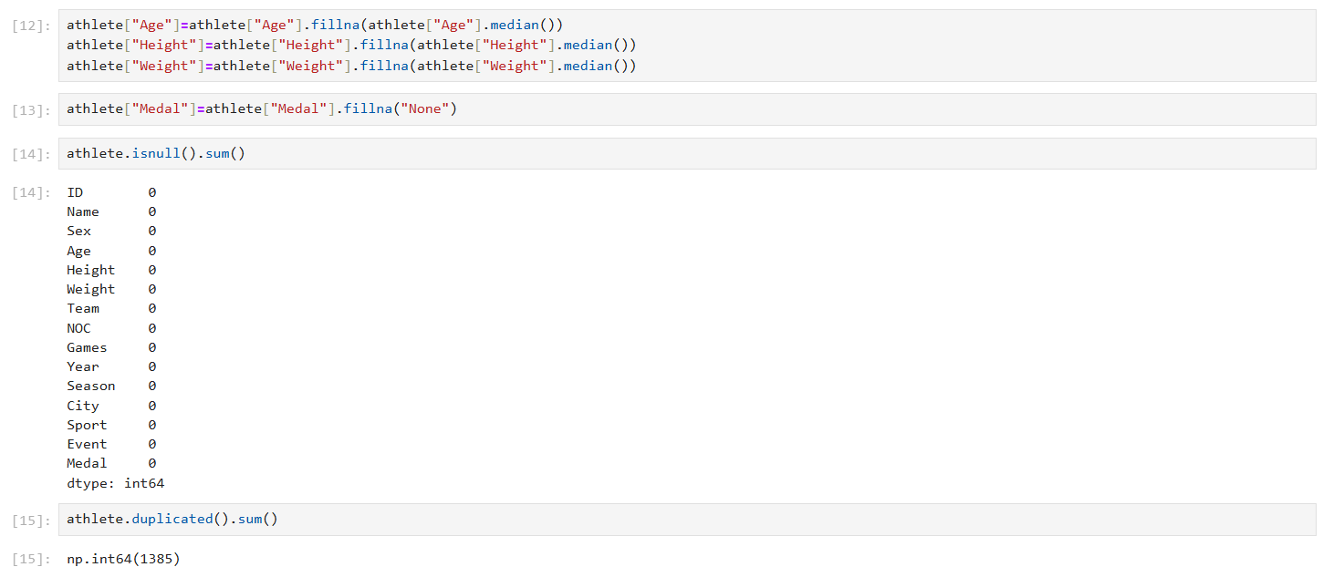

4. Bivariate and Multivariate Analysis

- Analyze relationships between variables:

  - How medal count changes over years
  - Country vs. medal performance
  - Gender vs. participation trends
  - Age/Height/Weight vs. medal winners

- Use groupby(), pivot_table(), heatmap() to find correlations

5. Visualization of Key Insights

- Create visual dashboards using:
  - matplotlib and seaborn for static charts
  - plotly or dash for interactive visuals
  - Maps using plotly.express to show medals by country.
Analysis on Dataset (for each analysis)

1. Count number of Medal on Basis of Year and Team

i. Introduction

This analysis focuses on how participation in the Olympics has changed over time, highlighting trends in athlete involvement based on different years, teams, and medal achievements.

ii. General Description

We grouped the dataset by Year, Team, and Medal to examine how athlete participation has evolved. The aim is to identify how countries have increased their presence and performance in the Olympics across time.

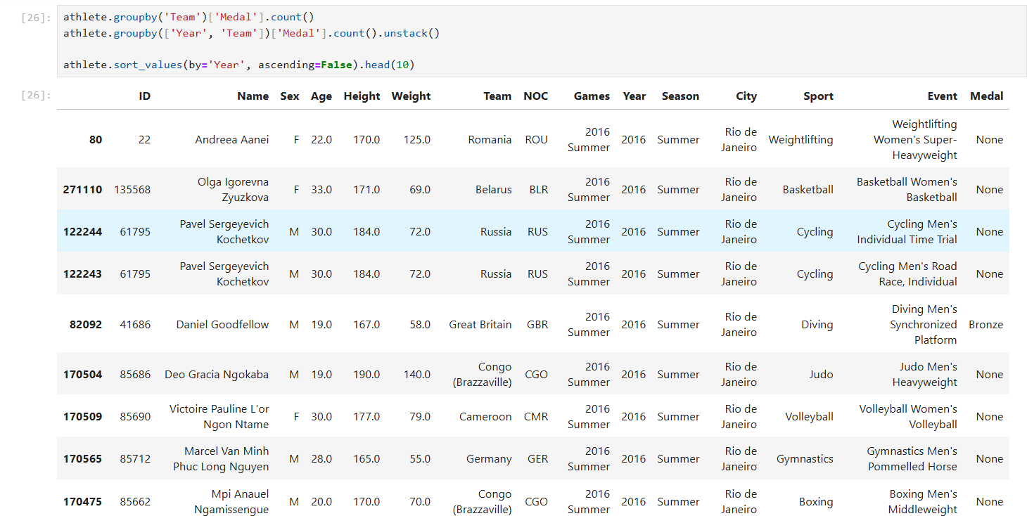

2. Unique count of Sports, events, city and Teams participated in Olympics

i. Introduction
This analysis highlights the diversity and global reach of the Olympic Games by counting the number of unique sports, events, host cities, and participating teams throughout Olympic history.

ii. General Description
By examining unique entries in the Sport, Event, City, and Team columns, we can understand how the Olympics have expanded in scope and participation across the decades.

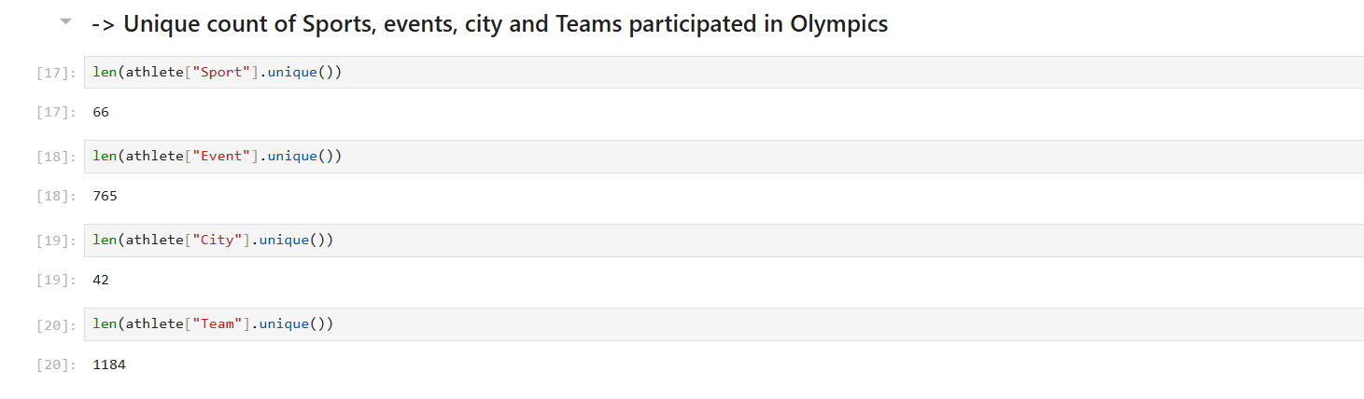

ii. Specific Requirements, Functions, and Formulas
- nunique() – Used to count unique values in each column
- Optionally, set() can also be used for previewing unique entries
- Visualizations include bar plots and donut charts

iv. Analysis Results
- The Olympics have featured a large variety of sports and thousands of unique events.
- Hosted by multiple cities across continents, the event has truly become global.
- A wide range of teams (nations/regions) have taken part, reflecting increasing inclusivity.

V. Visualization
1. Bar Plot – Count of Unique Entries

3. Medal Distribution

i. Introduction

This analysis focuses on the distribution of medals (Gold, Silver, Bronze) awarded throughout Olympic history. It helps to understand the overall medal count and compare how often each type of medal is awarded.

ii. General Description

We use the Medal column to count the total number of Gold, Silver, and Bronze medals won. This simple yet insightful analysis gives a clear picture of the frequency and balance of medals distributed.

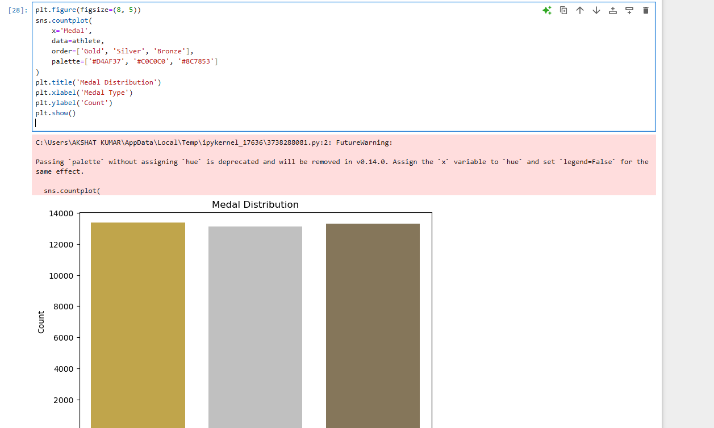

iii. Specific Requirements, Functions, and Formulas

- sns.countplot() – Used to create a bar plot of medal counts
- order=['Gold', 'Silver', 'Bronze'] – Ensures medals are displayed in correct sequence
- palette – Used to color medals in real-world shades
- Dataset: athlete DataFrame with valid Medal entries

iv. Analysis Results

- The bar plot shows the total count of each medal type.
- Bronze medals are typically higher in count due to some sports awarding two bronze medals.
- The distribution confirms the standard Olympic awarding system across all years.

v. Visualization

The bar plot clearly visualizes the counts of Gold, Silver, and Bronze medals, with appropriate coloring for realism and clarity.
Let me know if you want a pie or donut version of this as well!

4. Top 10 Countries by Gold Medals

i. Introduction

This analysis identifies the top 10 countries that have secured the highest number of Gold medals in Olympic history. It provides insight into the nations with the most dominant performances over the years.

ii. General Description

The data is filtered for rows where the medal type is 'Gold'. Then, the number of gold medals is counted per team (country), and the top 10 are selected and visualized.

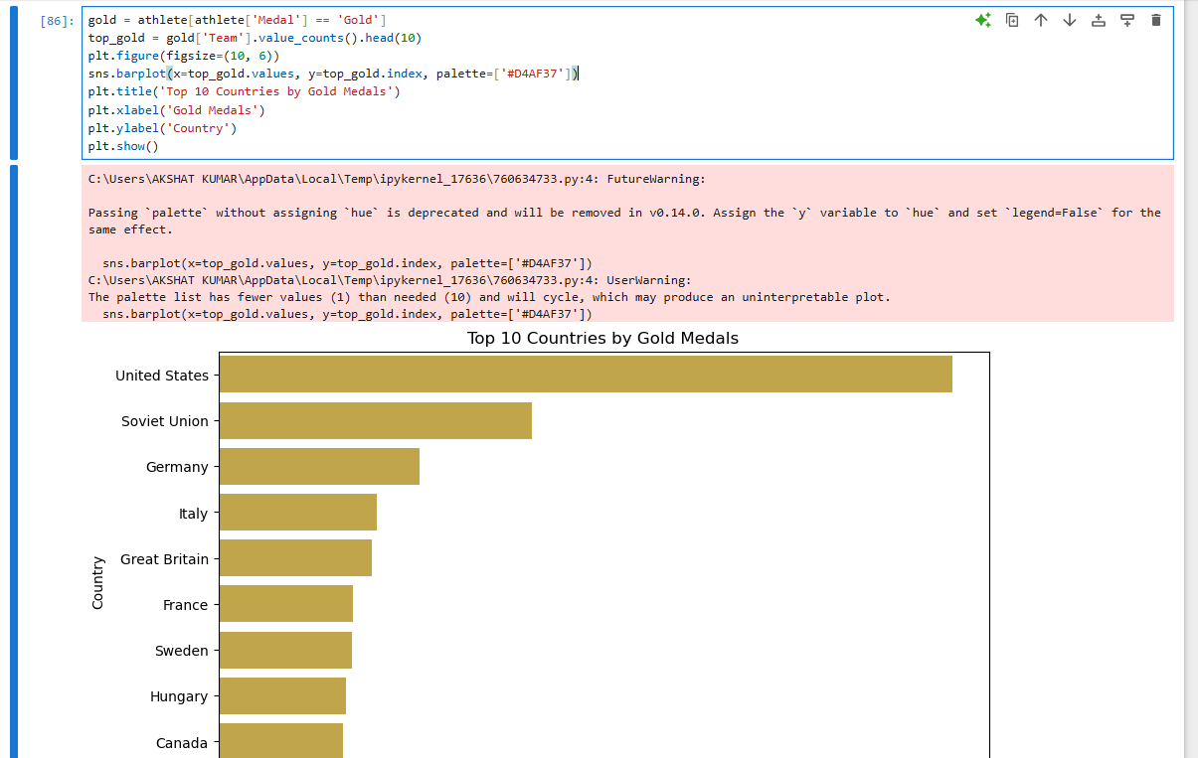

iii. Specific Requirements, Functions, and Formulas

- athlete[athlete['Medal'] == 'Gold'] – Filters the dataset to include only Gold medals
- value_counts() – Counts occurrences of each country
- head (10) – Retrieves the top 10 teams
- sns.barplot() – Used to plot the horizontal bar chart
- palette=['#D4AF37'] – Color set to gold for visual representation

iv. Analysis Results

- Countries like the USA, Russia, and Germany dominate the gold medal tally.
- The plot reveals the competitive edge and sporting excellence of these nations over multiple Olympic events.

v. Visualization

A horizontal bar plot highlights the top 10 countries by their gold medal counts. Using gold coloring makes the chart visually intuitive and theme-consistent.

5. Gender Distribution of Medal Winners

i. Introduction

This analysis examines the gender breakdown among athletes who have won Olympic medals. It helps in understanding the representation and achievements of male and female athletes in the history of the Games.

ii. General Description

The dataset is filtered to include only athletes who have won medals. The number of male and female medal winners is then calculated and displayed in a pie chart to show the proportion of each gender.

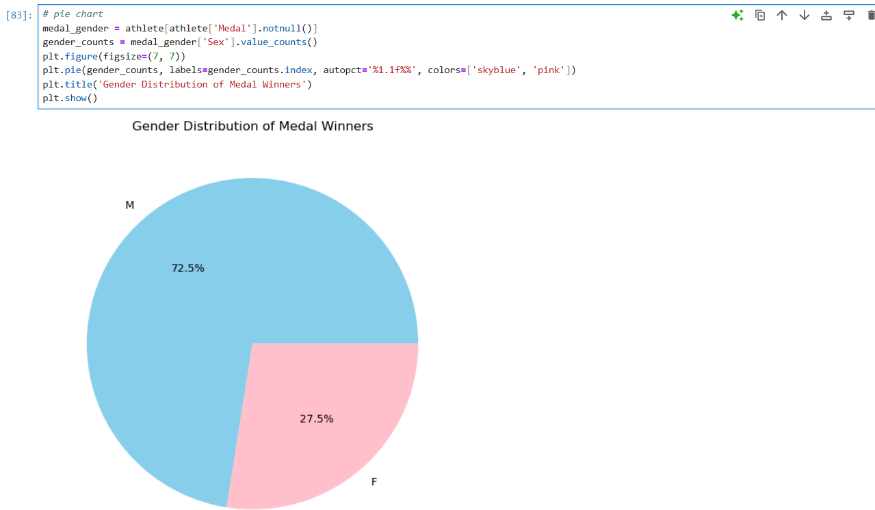

iii. Specific Requirements, Functions, and Formulas

- athlete['Medal'].notnull() – Filters only those rows where the athlete has won a medal
- value_counts() – Counts occurrences of each gender (Sex)
- plt.pie() – Generates the pie chart for visual comparison
- autopct='%1.1f%%' – Displays percentage values on the chart
- colors=['skyblue', 'pink'] – Assigns distinct colors for male and female

iv. Analysis Results

- The pie chart typically shows that male athletes have historically won more medals than female athletes.
- However, the share of female winners has been increasing in recent Olympics, reflecting improved gender parity in sports.

v. Visualization

A pie chart is used to represent the percentage of male and female medal winners. The use of intuitive colors (blue and pink) makes the chart easily interpretable.

6. Top 10 Teams Winning Gold in Summer Olympics

i. Introduction

This analysis highlights the top 10 countries that have won the most Gold medals in the Summer Olympics, showcasing dominance in summer sports events over the years.

ii. General Description

The dataset is filtered to include only Gold medal winners from the Summer Olympics. The top 10 countries based on the number of these medals are then visualized using a donut pie chart.

iii. Specific Requirements, Functions, and Formulas

- athlete[(athlete['Medal'] == 'Gold') & (athlete['Season'] == 'Summer')] – Filters data for Gold medals in the Summer Olympics
- value_counts().head(10) – Gets the top 10 countries with most golds
- plt.pie() – Used to create a donut-style pie chart with wedgeprops=dict(width=0.4)
- sns.color_palette('pastel') – Applies soft colors for aesthetic clarity
- startangle=140 – Adjusts the starting angle for better visual rotation

iv. Analysis Results

- The donut chart shows the USA leading in gold medals during Summer Olympics, followed by countries like Russia, Germany, and China.
- The visualization reveals how a few nations consistently dominate Summer Olympic events.

v. Visualization

A donut-style pie chart displays the percentage share of gold medals among the top 10 teams in Summer Olympics. The clean layout and pastel color palette improve readability and appeal.

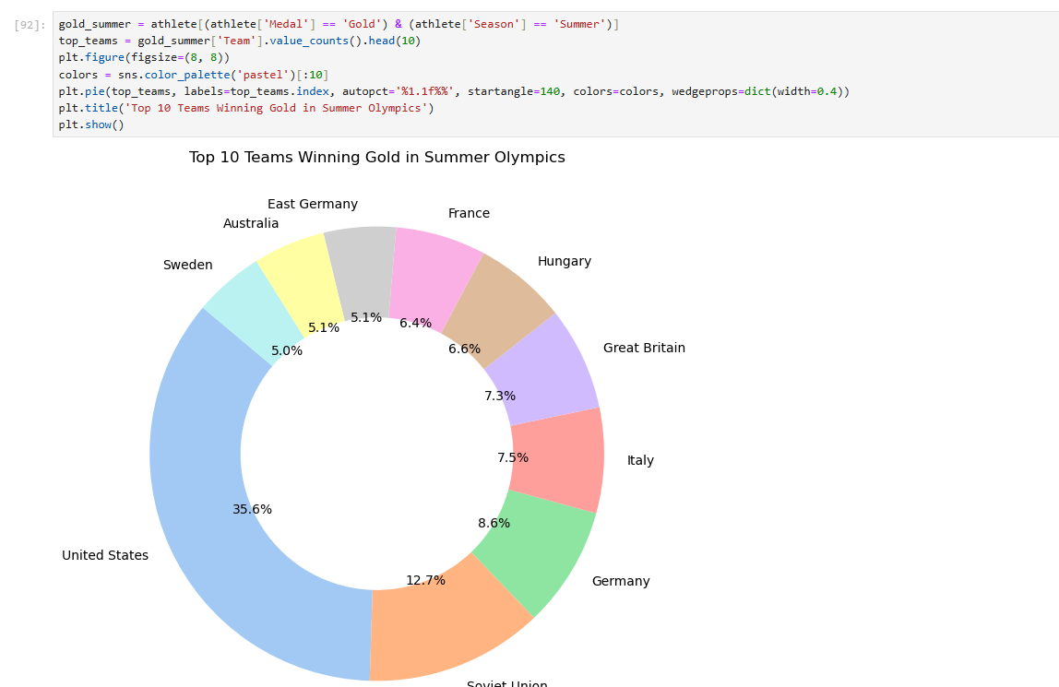

7. Encoding Medal Column

i. Introduction

This analysis focuses on converting categorical medal types (Gold, Silver, Bronze, and NaN) into numeric values for easier processing in machine learning models and statistical analysis.

ii. General Description

Since machine learning algorithms require numerical input, the Medal column (which contains string values) is converted into numerical labels using Label Encoding. This transformation helps in modeling and statistical computations involving medal types.

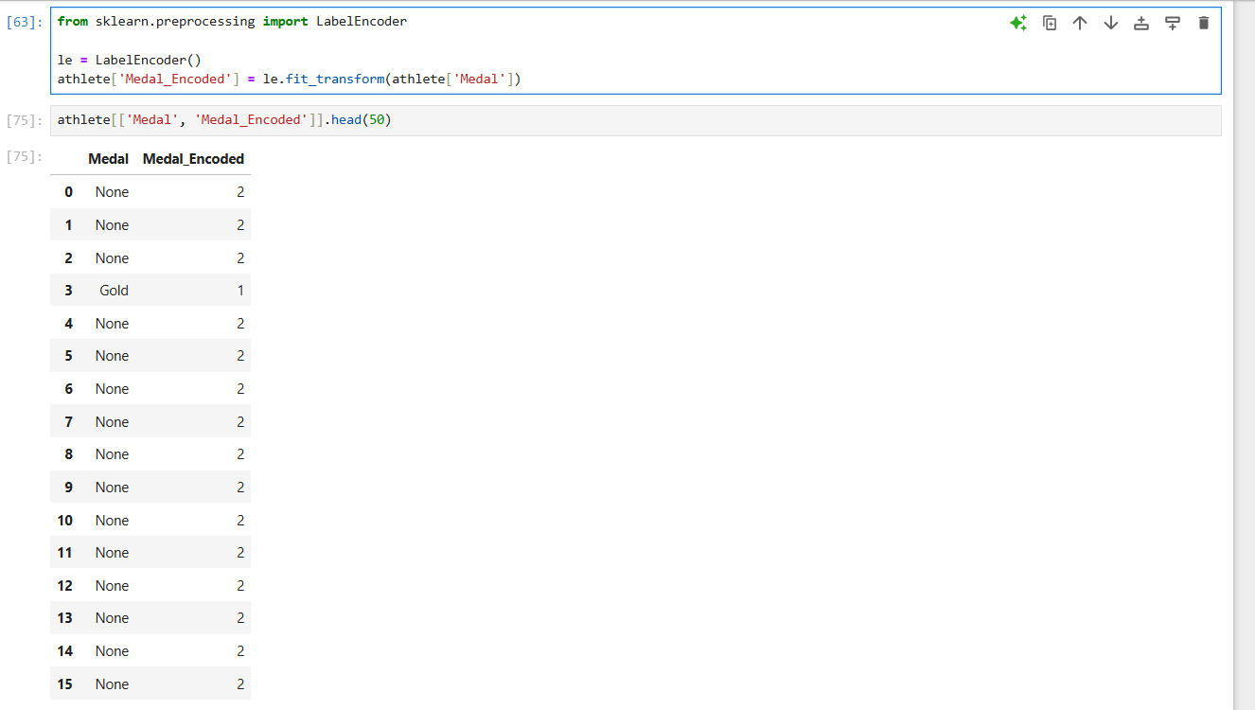

iii. Specific Requirements, Functions, and Formulas

- from sklearn.preprocessing import LabelEncoder – Imports the label encoder tool from scikit-learn
- LabelEncoder() – Initializes the encoder
- le.fit_transform() – Transforms categorical values into integers
- A new column Medal_Encoded is added to the dataframe to store the encoded values

iv. Analysis Results

- The Medal_Encoded column now contains numerical values corresponding to medal types.
- This is particularly useful for correlation analysis, regression, or any model that requires numeric input features.

v. Visualization

While this encoding step itself may not require visualization, you could plot a bar graph showing encoded medal counts for better understanding:

CONCLUSION

This project, “120 Years of Olympic History: Analysis and Visualization using Python,” provided an in-depth exploration of one of the world’s most prestigious sporting events—the Olympic Games. Through extensive Exploratory Data Analysis (EDA), this project unveiled valuable insights into the evolution of the Olympics from its inception to the modern era.

The dataset, sourced from Kaggle, contains historical data about athletes, events, medals, cities, teams, and more, spanning from 1896 to 2016. Using powerful Python libraries such as Pandas, NumPy, Matplotlib, and Seaborn, the data was cleaned, structured, and visualized to uncover meaningful trends and patterns.
Key highlights of the project include:
- Gender Participation Trends: The analysis illustrated the growing involvement of women in the Olympics, highlighting how gender equality has progressed significantly over the decades.
- Medal Distribution: Using bar charts and pie charts, the project visualized the total distribution of medals by type and gender, revealing which nations and genders dominated certain periods.
- Top Performing Nations: With the help of bar plots and donut charts, the project showcased the top 10 countries that have consistently performed well, especially in the Summer Olympics, emphasizing their dominance in various sports.
- Diversity of Participation: The project computed and visualized the number of unique cities, sports, events, and teams, highlighting the global nature and widespread reach of the Olympic Games.
- Categorical Encoding for Machine Learning: Label Encoding was applied to convert categorical features like medals into numerical values, preparing the dataset for potential future use in predictive modeling.
- Each visualization and analysis not only enriched our understanding of the data but also added a visual dimension to historical Olympic facts. It was evident how the Games have expanded in scale, diversified in sports and countries, and evolved with time socially and politically.

Each visualization and analysis not only enriched our understanding of the data but also added a visual dimension to historical Olympic facts. It was evident how the Games have expanded in scale, diversified in sports and countries, and evolved with time socially and politically.
This project reflects the power of data storytelling, where raw numbers are transformed into engaging insights. With Python's versatile ecosystem and a structured EDA pipeline, historical sports data was made interactive, meaningful, and ready for advanced analytics and machine learning applications.

Future Scope

This project provides a strong foundation for further research and innovation in the field of sports analytics, especially regarding the Olympic Games. One significant area of extension is predictive analytics, where machine learning models can be developed to forecast medal outcomes for countries and athletes based on historical performance data. Time series analysis can also be employed to predict trends in athlete participation and medal distribution across future Olympic events. Additionally, integrating real-time data from upcoming games through APIs would keep the analysis dynamic and up to date. Another promising direction is the creation of interactive dashboards using tools like Streamlit or Plotly Dash, enabling users to explore Olympic data through customizable visual interfaces. The application of deep learning and natural language processing (NLP) techniques could open new possibilities such as sentiment analysis of athlete interviews or image recognition for event footage. Comparative studies between Summer and Winter Olympics, or among continents, can further enhance the understanding of global sports dynamics. Moreover, analyzing gender, age, and regional diversity in greater depth can contribute valuable insights into social and cultural progress in sports. Overall, this project can evolve into a comprehensive platform for both historical and forward-looking analysis of the Olympic Games, combining data science with the spirit of global athleticism.
References

- Maven Analytics – Olympic Games Dataset
https://mavenanalytics.io/data-playground?accessType=open&dataStructure=Single%20table&dataStructure=Multiple%20tables&order=date_added%2Cdesc&tags=Sports

- Pandas Documentation
https://pandas.pydata.org/docs/

- Matplotlib Documentation
https://matplotlib.org/stable/contents.html

- Seaborn Documentation
https://seaborn.pydata.org/

- Scikit-learn Documentation
https://scikit-learn.org/stable/

- Python Official Documentation
https://docs.python.org/3/

GITHUB LINK

https://github.com/Akshat-Kumar07/Python-Project.git

